Assignment

**Step1 - Launching**

import pandas as pd

import numpy as np

import matplotlib.pyplot as plt

dataset1=pd.read_excel(‘general_data.xlsx', sheet_name=0)

dataset1.head()

Out[12]:

Age Attrition ... YearsSinceLastPromotionYearsWithCurrManager

0 51 No ... 0 0

1 31 Yes ... 1 4

2 32 No ... 0 3

3 38 No ... 7 5

4 32 No ... 0 4

[5 rows x 18 columns]

>>>dataset1.columns

Out[3]:

Index(['Age', 'Attrition', 'BusinessTravel', 'Department', 'DistanceFromHome',

'Education', 'EducationField', 'Gender', 'JobRole', 'MaritalStatus',

'MonthlyIncome', 'NumCompaniesWorked', 'PercentSalaryHike',

'TotalWorkingYears', 'TrainingTimesLastYear', 'YearsAtCompany',

'YearsSinceLastPromotion', 'YearsWithCurrManager'],

dtype='object')

**Step 2 - Data Treatment:**

>>>dataset1.isnull()

Out[47]:

Age Attrition ... YearsSinceLastPromotionYearsWithCurrManager

0 False False ... False False

1 False False ... False False

2 False False ... False False

3 False False ... False False

4 False False ... False False

... ... ... ... ...

4405 False False ... False False

4406 False False ... False False

4407 False False ... False False

4408 False False ... False False

4409 False False ... False False

[4410 rows x 18 columns]

>>>dataset1.duplicated()

Out[23]:

0 False

1 False

2 False

3 False

4 False

4405 True

4406 True

4407 True

4408 True

4409 False

Length: 4410, dtype: bool

>>>dataset1.drop_duplicates()

Out[1]:

Age Attrition ... YearsSinceLastPromotionYearsWithCurrManager

0 51 No ... 0 0

1 31 Yes ... 1 4

2 32 No ... 0 3

3 38 No ... 7 5

4 32 No ... 0 4

... ... ... ... ...

3818 28 Yes ... 0 0

3910 41 No ... 1 2

4226 36 No ... 0 0

4395 40 No ... 4 7

4409 40 No ... 3 9

[1498 rows x 18 columns]

**Step 3 – Univariate Analysis:**

>>>dataset3=dataset1[['Age','DistanceFromHome','Education','MonthlyIncome', 'NumCompaniesWorked', 'PercentSalaryHike','TotalWorkingYears']].describe()

>>>dataset3

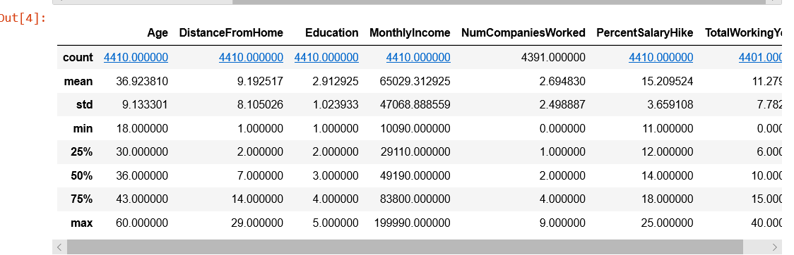

>>>dataset3=dataset1[['Age','DistanceFromHome','Education','MonthlyIncome', 'NumCompaniesWorked', 'PercentSalaryHike','TotalWorkingYears', 'TrainingTimesLastYear', 'YearsAtCompany','YearsSinceLastPromotion', 'YearsWithCurrManager']].median()

>>>dataset3

Out[2]:

Age 36.0

DistanceFromHome 7.0

Education 3.0

MonthlyIncome 49190.0

NumCompaniesWorked 2.0

PercentSalaryHike 14.0

TotalWorkingYears 10.0

TrainingTimesLastYear 3.0

YearsAtCompany 5.0

YearsSinceLastPromotion 1.0

YearsWithCurrManager 3.0

dtype: float64

>>>dataset3=dataset1[['Age','DistanceFromHome','Education','MonthlyIncome', 'NumCompaniesWorked', 'PercentSalaryHike','TotalWorkingYears', 'TrainingTimesLastYear', 'YearsAtCompany','YearsSinceLastPromotion', 'YearsWithCurrManager']].mode()

>>>dataset3

Out[69]:

Age 35

DistanceFromHome 2

Education 3

MonthlyIncome 23420

NumCompaniesWorked 1

PercentSalaryHike 11

TotalWorkingYears 10

TrainingTimesLastYear 2

YearsAtCompany 5.0

YearsSinceLastPromotion 0

YearsWithCurrManager 2

dtype: float64

>>>dataset3=dataset1[['Age','DistanceFromHome','Education','MonthlyIncome', 'NumCompaniesWorked', 'PercentSalaryHike','TotalWorkingYears', 'TrainingTimesLastYear', 'YearsAtCompany','YearsSinceLastPromotion', 'YearsWithCurrManager']].var()

>>>dataset3

output-1

Age 8.341719e+01

DistanceFromHome 6.569144e+01

Education 1.048438e+00

MonthlyIncome 2.215480e+09

NumCompaniesWorked 6.244436e+00

PercentSalaryHike 1.338907e+01

TotalWorkingYears 6.056298e+01 TrainingTimesLastYear 1.661465e+00

YearsAtCompany 3.751728e+01 YearsSinceLastPromotion 1.037935e+01 YearsWithCurrManager 1.272582e+01

dtype: float64

dataset3=dataset1[['Age','DistanceFromHome','Education','MonthlyIncome', 'NumCompaniesWorked', 'PercentSalaryHike','TotalWorkingYears', 'TrainingTimesLastYear', 'YearsAtCompany','YearsSinceLastPromotion', 'YearsWithCurrManager']].skew()

dataset3

Out[5]:Age 0.413005

DistanceFromHome 0.957466

Education -0.289484

MonthlyIncome 1.368884

NumCompaniesWorked 1.026767

PercentSalaryHike 0.820569

TotalWorkingYears 1.116832

TrainingTimesLastYear 0.552748

YearsAtCompany 1.763328

YearsSinceLastPromotion 1.982939

YearsWithCurrManager 0.832884

dtype: float64

dataset3=dataset1[['Age','DistanceFromHome','Education','MonthlyIncome', 'NumCompaniesWorked', 'PercentSalaryHike','TotalWorkingYears', 'TrainingTimesLastYear', 'YearsAtCompany','YearsSinceLastPromotion', 'YearsWithCurrManager']].kurt()

dataset3

Age -0.405951

DistanceFromHome -0.227045 Education -0.560569

MonthlyIncome 1.000232 NumCompaniesWorked 0.007287 PercentSalaryHike -0.302638 TotalWorkingYears 0.912936 TrainingTimesLastYear 0.491149 YearsAtCompany 3.923864 YearsSinceLastPromotion 3.601761 YearsWithCurrManager 0.167949 dtype: float64

Inference from the **analysis:**

• All the above variables show positive skewness; while Age &Mean_distance_from_home are leptokurtic and all other variables are platykurtic.

• The Mean_Monthly_Income’s IQR is at 54K suggesting company wide attrition across all income bands

• Mean age forms a near normal distribution with 13 years of IQR

**Outliers:**

There’s no regression found while plotting Age, MonthlyIncome

, TotalWorkingYears, YearsAtCompany, etc., on a scatter plot

box_plot=dataset1.Age plt.boxplot(box_plot)

Out[23]:

**{'whiskers': [<matplotlib.lines.Line2D at 0x1ed72394608>, <matplotlib.lines.Line2D at 0x1ed723ae708>], 'caps': [<matplotlib.lines.Line2D at 0x1ed723aedc8>, <matplotlib.lines.Line2D at 0x1ed723b2f48>], 'boxes': [<matplotlib.lines.Line2D at 0x1ed723a3288>], 'medians': [<matplotlib.lines.Line2D at 0x1ed723b6ec8>], 'fliers': [<matplotlib.lines.Line2D at 0x1ed723b9c48>], 'means': []}**

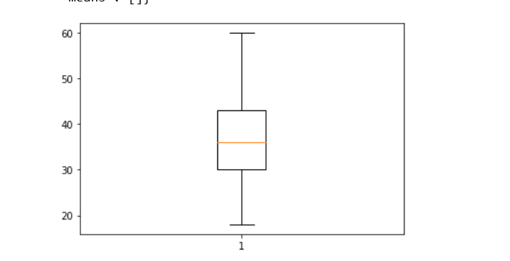

***Age is normally distributed without any outliers

>>>box_plot=dataset1.MonthlyIncome

>>>plt.boxplot(box_plot)

{'whiskers': [<matplotlib.lines.Line2D at 0x1ed7243c388>, <matplotlib.lines.Line2D at 0x1ed7243cb88>], 'caps': [<matplotlib.lines.Line2D at 0x1ed7243acc8>, <matplotlib.lines.Line2D at 0x1ed724365c8>], 'boxes': [<matplotlib.lines.Line2D at 0x1ed7243cec8>], 'medians': [<matplotlib.lines.Line2D at 0x1ed7242e4c8>], 'fliers': [<matplotlib.lines.Line2D at 0x1ed7242e5c8>], 'means': []}

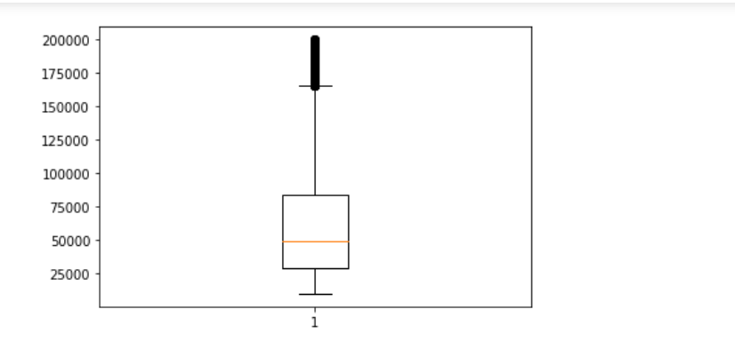

**Monthly Income is Right skewed with several outliers

>>>box_plot=dataset1.YearsAtCompany >>>plt.boxplot(box_plot)

Output:  
{'whiskers': [<matplotlib.lines.Line2D at 0x1ed6c21da08>, <matplotlib.lines.Line2D at 0x1ed6c21df88>], 'caps': [<matplotlib.lines.Line2D at 0x1ed6c21db88>, <matplotlib.lines.Line2D at 0x1ed6c21fa88>], 'boxes': [<matplotlib.lines.Line2D at 0x1ed6c21d308>], 'medians': [<matplotlib.lines.Line2D at 0x1ed6c21ff88>], 'fliers': [<matplotlib.lines.Line2D at 0x1ed6c21fc08>], 'means': []}

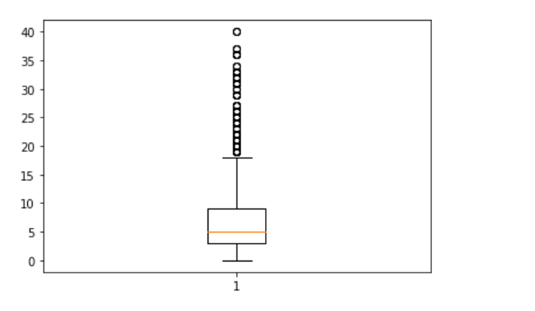

**Years at company is also Right Skewed with several outliers observed.

**Step 5 – Statistical Tests (Mann-Whitney)**

**Attrition VsDistancefromHome**

importpandasaspd

dataset=pd.read_excel('EmployeeAttrition.xlsx',sheet_name=1)

dataset.head()

Out[3]:

DistanceFromHome_Yes...YearsWithCurrManager_No

00...0

110...0

20...3

30...5

40...4

[5rows x10columns]

dataset.columns

Out[4]:

Index(['DistanceFromHome_Yes','DistanceFromHome_No','MonthlyIncome_Yes',

'MonthlyIncome_No','TotalWorkingYears_Yes','TotalWorkingYears_No',

'YearsAtCompany_Yes','YearsAtCompany_No','YearsWithCurrManager_Yes',

'YearsWithCurrManager_No'],

dtype='object')

fromscipy.stats importmannwhitneyu

a1=dataset.DistanceFromHome_Yes

a2=dataset.DistanceFromHome_No

stat,p=mannwhitneyu(a1,a2)

print(stat,p)

3132625.50.0

AstheP valueof0.0is<0.05, theH0is rejectedandHais accepted.

H0:Thereis nosignificantdifferencesintheDistanceFromHomebetweenattrition(Y)andattirition(N)

Ha:Thereis significantdifferencesintheDistanceFromHomebetweenattrition(Y)andattirition(N)

**Attrition Vs Income**

a1=dataset.MonthlyIncome_Yes

a2=dataset.MonthlyIncome_No

stat,p=mannwhitneyu(a1,a2)

print(stat,p)

3085416.00.0

AstheP valueisagain0.0, whichis <than0.05,theH0isrejectedandhaisaccepted.

H0:Thereis nosignificantdifferencesintheincomebetweenattrition(Y)andattirition(N)

Ha:Thereis significantdifferencesintheincomebetweenattrition(Y) andattirition(N)

**Attrition VsTotalWorkingYears**

a1=dataset.TotalWorkingYears_Yes

a2=dataset.TotalWorkingYears_No

stat,p=mannwhitneyu(a1,a2)

print(stat,p)

2760982.00.0

AstheP valueisagain0.0, whichis <than0.05,theH0isrejectedandhaisaccepted.

H0:Thereis nosignificantdifferencesintheTotalWorkingYearsbetweenattrition(Y)andattirition(N)

Ha:Thereis significantdifferencesintheTotalWorkingYearsbetweenattrition(Y)andattirition(N)

**Attrition VsYearsatcompany**

a1=dataset.YearsAtCompany_Yes

a2=dataset.YearsAtCompany_No

stat,p=mannwhitneyu(a1,a2)

print(stat,p)

2882047.50.0

AstheP valueisagain0.0, whichis <than0.05,theH0isrejectedandhaisaccepted.

H0:Thereis nosignificantdifferencesintheYearsAtCompanybetweenattrition(Y)andattirition(N)

Ha:Thereis significantdifferencesintheYears AtCompanybetweenattrition(Y) andattirition(N)

**Attrition VsYearsWithCurrentManager**

a1=dataset.YearsWithCurrManager_Yes

a2=dataset.YearsWithCurrManager_No

stat,p=mannwhitneyu(a1,a2)

print(stat,p)

3674749.50.0

AstheP valueisagain0.0, whichis <than0.05,theH0isrejectedandhaisaccepted.

H0:Thereis nosignificantdifferencesintheYearsWithCurrent Managerbetweenattrition(Y) andattirition(N)

Ha:Thereis significantdifferencesintheYearsWithCurrentManagerbetweenattrition(Y)andattirition(N)

**Step 6–StatisticalTests(SeparateTTest)**

**AttritionVsDistance FromHome**

fromscipy.stats importttest_ind

dataset.columns

Out[49]:

Index(['DistanceFromHome_Yes','DistanceFromHome_No','MonthlyIncome_Yes',

'MonthlyIncome_No','TotalWorkingYears_Yes','TotalWorkingYears_No',

'YearsAtCompany_Yes','YearsAtCompany_No','YearsWithCurrManager_Yes',

'YearsWithCurrManager_No'],

dtype='object')

z1=dataset.DistanceFromHome_Yes

z2=dataset.DistanceFromHome_No

stat,p=ttest_ind(z2,z1)

print(stat,p)

44.454459176366640.0

AstheP valueisagain0.0, whichis <than0.05,theH0isrejectedandhaisaccepted.

H0:Thereis nosignificantdifferencesintheDistanceFromHomebetweenattrition(Y) andattirition(N)

Ha:Thereis significantdifferencesintheDistanceFromHomebetweenattrition(Y)andattirition(N)

**AttritionVsIncome**

z1=dataset.MonthlyIncome_Yes

z2=dataset.MonthlyIncome_No

stat,p=ttest_ind(z2,z1)

print(stat,p)

52.092794085049470.0

AstheP valueisagain0.0, whichis <than0.05,theH0isrejectedandhaisaccepted.

H0:Thereis nosignificantdifferencesintheMonthlyIncomebetweenattrition(Y) andattirition(N)

Ha:Thereis significantdifferencesintheMonthly Incomebetweenattrition(Y)andattirition(N)

**AttritionVsYeatsAtCompany**

z1=dataset.YearsAtCompany_Yes

z2=dataset.YearsAtCompany_No

stat,p=ttest_ind(z2,z1)

print(stat,p)

51.452969415156920.0

AstheP valueisagain0.0, whichis<than0.05,theH0isrejectedandhaisaccepted.

H0:Thereis nosignificantdifferencesintheYearsAtCompanybetweenattrition(Y)andattirition(N)

Ha:Thereis significantdifferencesintheYears AtCompanybetween attrition(Y)andattirition(N)

**AttritionVsYears WithCurrentManager**

z1=dataset.YearsWithCurrManager_Yes

z2=dataset.YearsWithCurrManager_No

stat,p=ttest_ind(z2,z1)

print(stat,p)

53.024243490245210.0

AstheP valueisagain0.0, whichis <than0.05,theH0isrejectedandhaisaccepted.

H0:Thereis nosignificantdifferencesintheYearsWithCurrent Managerbetweenattrition(Y) andattirition(N)

Ha:Thereis significantdifferencesintheYears WithCurrentManagerbetweenattrition(Y) andattirition(N)

**Step 8–UnsupervisedLearning-CorrelationAnalysis**

dataset=pd.read_excel('EmployeeAtrrition.xlsx’,sheet_name=0)

fromscipy.stats importpearsonr

dataset['TotalWorkingYears']=dataset['TotalWorkingYears'].fillna(11.28)

dataset.columns

Out[258]:

Index(['Age','Attrition','BusinessTravel','Department','DistanceFromHome',

'Education','EducationField','Gender', 'JobRole','MaritalStatus',

'MonthlyIncome', 'NumCompaniesWorked','PercentSalaryHike',

'TotalWorkingYears', 'TrainingTimesLastYear','YearsAtCompany',

'YearsSinceLastPromotion','YearsWithCurrManager'],

dtype='object')

stats,p=pearsonr(dataset.Attrition,dataset.DistanceFromHome)

print(stats,p)

-0.0097301410101794380.5182860428049617

stats,p=pearsonr(dataset.Attrition,dataset.MonthlyIncome)

print(stats,p)

-0.0311762816981140250.0384274849060192

stats,p=pearsonr(dataset.Attrition,dataset.TotalWorkingYears)

print(stats,p)

-0.170111363559646465.4731597518148054e-30

stats,p=pearsonr(dataset.Attrition,dataset.YearsAtCompany)

print(stats,p)

-0.134392213989973863.163883122493571e-19

stats,p=pearsonr(dataset.Attrition,dataset.YearsWithCurrManager)

print(stats,p)

-0.156199315901624221.7339322652951965e-25

Theinferenceoftheabove analysisareasfollows:

**Attrition&DistanceFromHome:**

Asr=-0.009,there’s lownegativecorrelationbetweenAttritionandDistanceFromHome

AstheP valueof0.518is>0.05,weareacceptingH0andhencethere’snosignificantcorrelationbetweenAttrition&DistanceFromHome

**Attrition&MonthlyIncome:**

Asr=-0.031,there’s lownegativecorrelationbetweenAttritionandMonthlyIncome

AstheP valueof0.038is<0.05,weareacceptingHaandhencethere’ssignificantcorrelationbetweenAttrition&MonthlyIncome

**Attrition&TotalWorkingYears:**

Asr=-0.17,there’slownegativecorrelationbetweenAttritionandTotalWorkingYears

AstheP valueis<0.05,weareacceptingHaandhencethere’s significantcorrelationbetweenAttrition&TotalWorkingYears

**Attrition&YearsAtCompany:**

Asr=-0.1343,there’slownegativecorrelationbetweenAttritionandYearsAtCompany

AstheP valueis<0.05,weareacceptingHaandhencethere’s significantcorrelationbetweenAttrition&YearsAtCompany

**Attrition&YearsWithCurrManager:**

Asr=-0.1561,there’slownegativecorrelationbetweenAttritionandYearsWithCurrManager

AstheP valueis<0.05,weareacceptingHaandhencethere’s significantcorrelationbetweenAttrition&YearsWithCurrManager